

Rețele de calcualtoare II

Proiect 2021

**Profesor universitar: Cristian Niculiță**

**Student: Osanu Ioan-Aurel**

***Impartirea pe segmente***

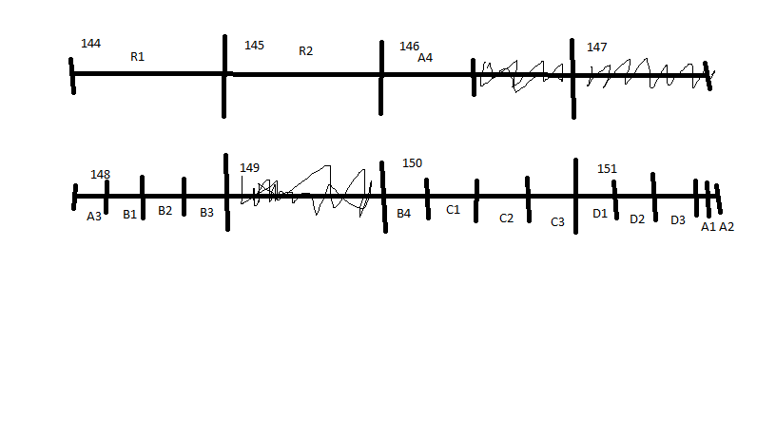

***Date proiect***

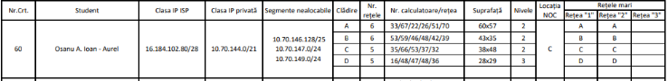

***Configurare router***

interface GigabitEthernet0/0

no ip address

ip nat inside

duplex auto

speed auto

!

interface GigabitEthernet0/0.10

encapsulation dot1Q 10

ip address 10.70.151.222 255.255.255.224

ip helper-address 10.70.150.253

ip nat inside

!

interface GigabitEthernet0/0.11

encapsulation dot1Q 11

ip address 10.70.151.254 255.255.255.224

ip helper-address 10.70.150.253

ip nat inside

!

interface GigabitEthernet0/0.12

encapsulation dot1Q 12

ip address 10.70.148.62 255.255.255.192

ip helper-address 10.70.150.253

ip nat inside

!

interface GigabitEthernet0/0.13

encapsulation dot1Q 13

ip address 10.70.146.126 255.255.255.128

ip helper-address 10.70.150.253

ip nat inside

!

interface GigabitEthernet0/0.14

encapsulation dot1Q 14

ip address 10.70.148.126 255.255.255.192

ip helper-address 10.70.150.253

ip nat inside

!

interface GigabitEthernet0/0.15

encapsulation dot1Q 15

ip address 10.70.148.190 255.255.255.192

ip helper-address 10.70.150.253

ip nat inside

!

interface GigabitEthernet0/0.16

encapsulation dot1Q 16

ip address 10.70.148.254 255.255.255.192

ip helper-address 10.70.150.253

ip nat inside

!

interface GigabitEthernet0/0.17

encapsulation dot1Q 17

ip address 10.70.150.62 255.255.255.192

ip helper-address 10.70.150.253

ip nat inside

!

interface GigabitEthernet0/0.18

encapsulation dot1Q 18

ip address 10.70.150.126 255.255.255.192

ip helper-address 10.70.150.253

ip nat inside

!

interface GigabitEthernet0/0.19

encapsulation dot1Q 19

ip address 10.70.150.190 255.255.255.192

ip helper-address 10.70.150.253

ip nat inside

!

interface GigabitEthernet0/0.21

encapsulation dot1Q 21

ip address 10.70.151.62 255.255.255.192

ip helper-address 10.70.150.253

ip nat inside

!

interface GigabitEthernet0/0.22

encapsulation dot1Q 22

ip address 10.70.151.126 255.255.255.192

ip helper-address 10.70.150.253

ip nat inside

!

interface GigabitEthernet0/0.23

encapsulation dot1Q 23

ip address 10.70.151.190 255.255.255.192

ip helper-address 10.70.150.253

ip nat inside

!

interface GigabitEthernet0/0.100

encapsulation dot1Q 100

ip address 10.70.144.254 255.255.255.0

ip helper-address 10.70.150.253

ip nat inside

!

interface GigabitEthernet0/0.200

encapsulation dot1Q 200

ip address 10.70.145.254 255.255.255.0

ip helper-address 10.70.150.253

ip nat inside

!

interface GigabitEthernet0/1

ip address 10.70.150.249 255.255.255.192

ip nat inside

duplex auto

speed auto

!

interface GigabitEthernet0/2

ip address 16.184.102.94 255.255.255.240

ip nat outside

duplex auto

speed auto

!

interface Vlan1

no ip address

shutdown

!

ip nat pool outside-addresses 16.184.102.81 16.184.102.94 netmask 255.255.255.240

ip nat inside source list 10 pool outside_addresses overload

ip nat inside source static 10.70.150.252 16.184.102.90

ip nat inside source static 10.70.150.253 16.184.102.88

ip nat inside source static 10.70.150.254 16.184.102.89

ip nat inside source static 10.70.150.251 16.184.102.91

ip nat inside source static 10.70.150.250 16.184.102.92

ip classless

!

ip flow-export version 9

!

!

access-list 10 permit 10.70.144.0 0.0.7.255

!

!

!

!

!

line con 0

!

line aux 0

!

line vty 0 4

login

!

!

!

End

***Configurarea unui switch dintr o clădire principal***

interface GigabitEthernet0/0

no ip address

ip nat inside

duplex auto

speed auto

!

interface GigabitEthernet0/0.10

encapsulation dot1Q 10

ip address 10.70.151.222 255.255.255.224

ip helper-address 10.70.150.253

ip nat inside

!

interface GigabitEthernet0/0.11

encapsulation dot1Q 11

ip address 10.70.151.254 255.255.255.224

ip helper-address 10.70.150.253

ip nat inside

!

interface GigabitEthernet0/0.12

encapsulation dot1Q 12

ip address 10.70.148.62 255.255.255.192

ip helper-address 10.70.150.253

ip nat inside

!

interface GigabitEthernet0/0.13

encapsulation dot1Q 13

ip address 10.70.146.126 255.255.255.128

ip helper-address 10.70.150.253

ip nat inside

!

interface GigabitEthernet0/0.14

encapsulation dot1Q 14

ip address 10.70.148.126 255.255.255.192

ip helper-address 10.70.150.253

ip nat inside

!

interface GigabitEthernet0/0.15

encapsulation dot1Q 15

ip address 10.70.148.190 255.255.255.192

ip helper-address 10.70.150.253

ip nat inside

!

interface GigabitEthernet0/0.16

encapsulation dot1Q 16

ip address 10.70.148.254 255.255.255.192

ip helper-address 10.70.150.253

ip nat inside

!

interface GigabitEthernet0/0.17

encapsulation dot1Q 17

ip address 10.70.150.62 255.255.255.192

ip helper-address 10.70.150.253

ip nat inside

!

interface GigabitEthernet0/0.18

encapsulation dot1Q 18

ip address 10.70.150.126 255.255.255.192

ip helper-address 10.70.150.253

ip nat inside

!

interface GigabitEthernet0/0.19

encapsulation dot1Q 19

ip address 10.70.150.190 255.255.255.192

ip helper-address 10.70.150.253

ip nat inside

!

interface GigabitEthernet0/0.21

encapsulation dot1Q 21

ip address 10.70.151.62 255.255.255.192

ip helper-address 10.70.150.253

ip nat inside

!

interface GigabitEthernet0/0.22

encapsulation dot1Q 22

ip address 10.70.151.126 255.255.255.192

ip helper-address 10.70.150.253

ip nat inside

!

interface GigabitEthernet0/0.23

encapsulation dot1Q 23

ip address 10.70.151.190 255.255.255.192

ip helper-address 10.70.150.253

ip nat inside

!

interface GigabitEthernet0/0.100

encapsulation dot1Q 100

ip address 10.70.144.254 255.255.255.0

ip helper-address 10.70.150.253

ip nat inside

!

interface GigabitEthernet0/0.200

encapsulation dot1Q 200

ip address 10.70.145.254 255.255.255.0

ip helper-address 10.70.150.253

ip nat inside

!

interface GigabitEthernet0/1

ip address 10.70.150.249 255.255.255.192

ip nat inside

duplex auto

speed auto

!

interface GigabitEthernet0/2

ip address 16.184.102.94 255.255.255.240

ip nat outside

duplex auto

speed auto

!

interface Vlan1

no ip address

shutdown

!

ip nat pool outside-addresses 16.184.102.81 16.184.102.94 netmask 255.255.255.240

ip nat inside source list 10 pool outside_addresses overload

ip nat inside source static 10.70.150.252 16.184.102.90

ip nat inside source static 10.70.150.253 16.184.102.88

ip nat inside source static 10.70.150.254 16.184.102.89

ip nat inside source static 10.70.150.251 16.184.102.91

ip nat inside source static 10.70.150.250 16.184.102.92

ip classless

!

ip flow-export version 9

!

!

access-list 10 permit 10.70.144.0 0.0.7.255

!

!

!

!

!

line con 0

!

line aux 0

!

line vty 0 4

login

!

!

!

End

16.184.102.80/28 Masca: 255.255.255.240

………………

16.184.102.88 DHCP

16.184.102.89 DNS

16.184.102.90 HTTP

16.184.102.91 FTP

16.184.102.92 MAIL

16.184.102.93 PC0

16.184.102.94 int gig0/2

16.184.102.95

10.70.144.0/21 2048

Segmente nealocabile

10.70.146.128/25

10.70.147.0/24

10.70.149.0/24

(33)/(67)/22/26/51/70 A A

(53)/(59)/46/48/42/39 B B

(35)/(66)/53/37/32 C C

(16)/(48)/47/48/36 D D

R1 33+53+35+16=137 (256)/24 255.255.255.0 Vlan100

10.70.144.0

………

10.70.144.254 int gig0/0.100

10.70.144.255

R2 67+59+66+48=240 (256)/24 255.255.255.0 Vlan200

10.70.145.0

………………..

10.70.145.254 int gig0/0.200

10.70.145.255

A1 22 -- 32 255.255.255.224 = 27 Vlan10

10.70.151.192

………………………

10.70.151.222 int gig0/0.10

10.70.151.223

A2 26 – 32 255.255.255.224 = 27 Vlan11

10.70.151.224

………………………

10.70.151.254 int gig0/0.11

10.70.151.255

**A3 51 -- 64** 255.255.255.192 = 26 Vlan12

10.70.148.0

…………………..

10.70.148.62 int gig0/0.12

10.70.148.63

**A4 70 -- 128** 255.255.255.128 = 25 Vlan13

10.70.146.0

……………………

10.70.146.126 int gig0/0.13

10.70.146.127

B1 46 -- 64 255.255.255.192 = 26 Vlan14

10.70.148.64

…………………….

10.70.148.126 int gig0/0.14

10.70.148.127

B2 48 -- 64 255.255.255.192 = 26 Vlan15

10.70.148.128

…………………….

10.70.148.190 int gig0/0.15

10.70.148.191

B3 42 -- 64 255.255.255.192 = 26 Vlan16

10.70.148.192

………………………

10.70.148.254 int gig0/0.16

10.70.148.255

B4 39 -- 64 255.255.255.192 = 26 Vlan17

10.70.150.0

…………………

10.70.150.62 int gig0/0.17

10.70.150.63

C1 53 -- 64 255.255.255.192 = 26 Vlan18

10.70.150.64

………………….

10.70.150.126 int gig0/0.18

10.70.150.127

C2 37 – 64 255.255.255.192 = 26 Vlan19

10.70.150.128

………………………

10.70.150.190 int gig0/0.19

10.70.150.191

C3 32 -- 64 255.255.255.192 = 26 NOC

10.70.150.192

………………………

10.70.150.249 – gig 0/1

10.70.150.250 - MAIL

10.70.150.251 - FTP

10.70.150.252 - HTTP

10.70.150.253 - DHCP

10.70.150.254 - DNS

10.70.150.255

D1 47 -- 64 255.255.255.192 = 26 Vlan21

10.70.151.0

…………………….

10.70.151.62 int gig0/0.21

10.70.151.63

D2 48 -- 64 255.255.255.192 = 26 Vlan22

10.70.151.64

……………………..

10.70.151.126 int gig0/0.22

10.70.151.127

D3 36 -- 64 255.255.255.192 = 26 Vlan23

10.70.151.128

……………………….

10.70.151.190 int gig0/0.23

10.70.151.191